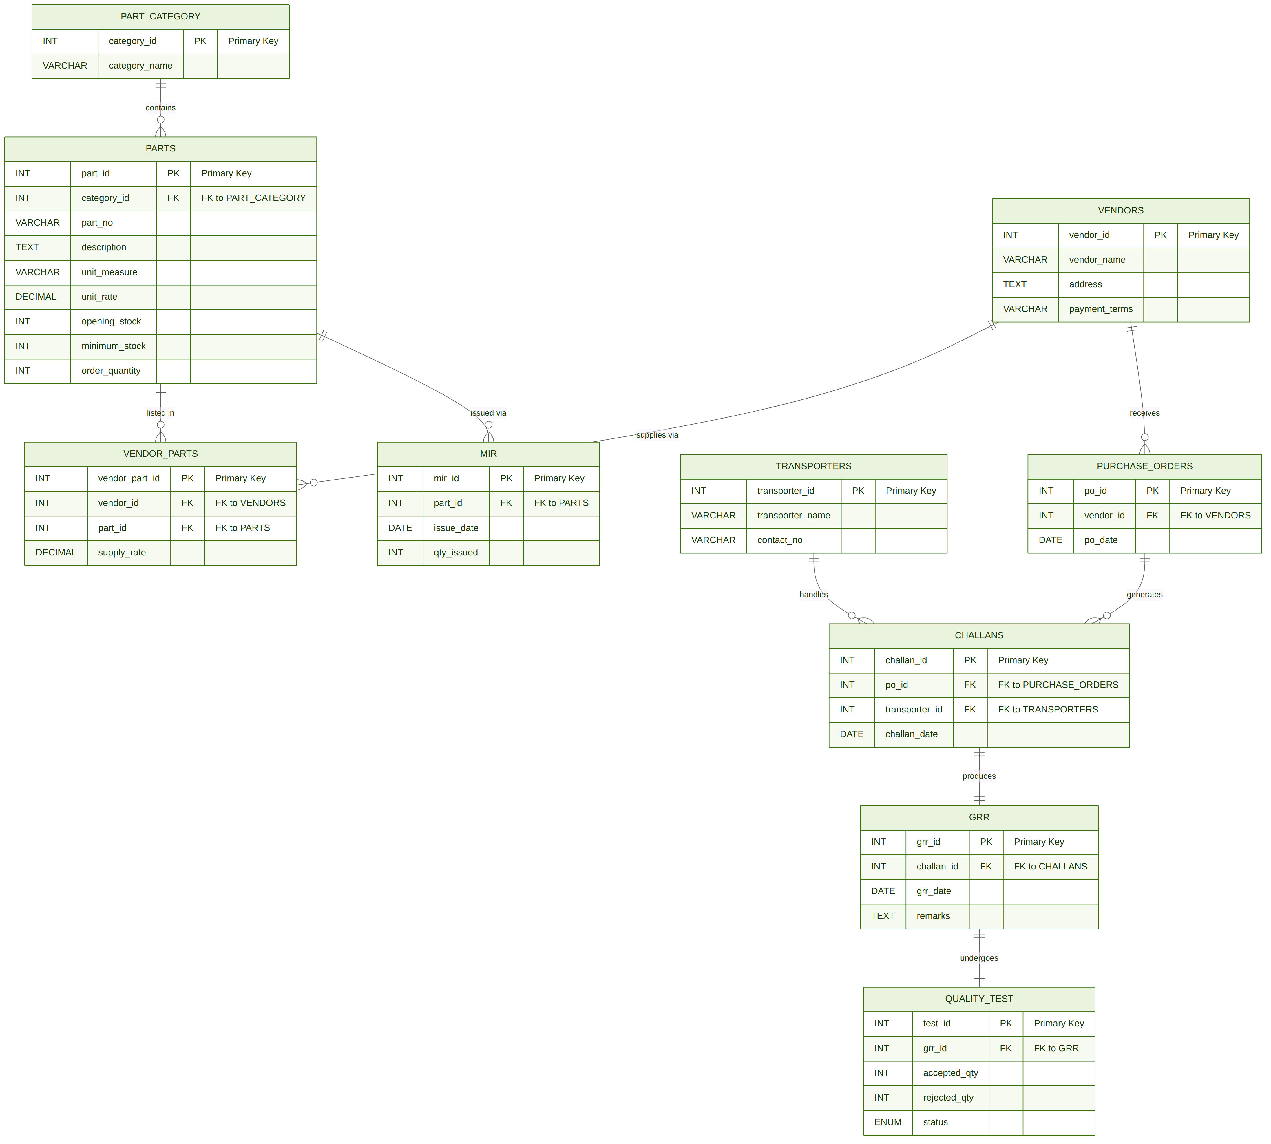

2. Relationships & Business Rules
All 9 relationships between entities, their cardinality, and the corresponding business rules are listed below.

# | From | To | Type | Business Rule
1 | PART_CATEGORY | PARTS | 1 : M | One category contains many parts
2 | PARTS | VENDOR_PARTS | 1 : M | One part can appear in many vendor-part records
3 | VENDORS | VENDOR_PARTS | 1 : M | One vendor can supply many parts
4 | VENDORS | PURCHASE_ORDERS | 1 : M | One vendor receives many purchase orders
5 | PURCHASE_ORDERS | CHALLANS | 1 : M | One PO can generate multiple challans
6 | TRANSPORTERS | CHALLANS | 1 : M | One transporter handles many challans
7 | CHALLANS | GRR | 1 : 1 | Each challan produces exactly one GRR
8 | GRR | QUALITY_TEST | 1 : 1 | Each GRR undergoes exactly one quality test
9 | PARTS | MIR | 1 : M | One part can appear in many MIR records

3. Normalization (3NF)
The database is designed to satisfy First, Second, and Third Normal Forms, eliminating all redundancy and data anomalies.

NF | Name | How this schema satisfies it
1NF | First Normal Form | All attributes contain atomic values. No repeating groups or multi-valued columns in any table.
2NF | Second Normal Form | All non-key attributes are fully functionally dependent on the entire primary key. No partial dependencies exist.
3NF | Third Normal Form | All non-key attributes depend only on the primary key. No transitive dependencies exist between non-key attributes.

4. Entity Attribute Reference
Detailed attribute listing for all 10 entities. PK = Primary Key (green), FK = Foreign Key (blue).

4.1 PART_CATEGORY
PART_CATEGORY
Attribute | Data Type | Description | Key
category_id | INT | Unique identifier for each part category | PK
category_name | VARCHAR | Name of the category (e.g., Raw Material, Component)

4.2 PARTS
PARTS
Attribute | Data Type | Description | Key
part_id | INT | Unique identifier for each part | PK
category_id | INT | Reference to part category | FK
part_no | VARCHAR | Part number used in procurement documents
description | TEXT | Full description of the part
unit_measure | VARCHAR | Unit of measurement (e.g., Kg, Nos, Ltr)
unit_rate | DECIMAL | Standard cost per unit of this part
opening_stock | INT | Initial stock quantity at the start of the period
minimum_stock | INT | Reorder trigger level — raise PO when below this
order_quantity | INT | Standard quantity to order per purchase order

4.3 VENDORS
VENDORS
Attribute | Data Type | Description | Key
vendor_id | INT | Unique identifier for each vendor | PK
vendor_name | VARCHAR | Registered name of the vendor/supplier
address | TEXT | Full postal address of the vendor
payment_terms | VARCHAR | Agreed payment terms (e.g., Net 30, COD)

4.4 VENDOR_PARTS (junction table — resolves M:M)
VENDOR_PARTS
Attribute | Data Type | Description | Key
vendor_part_id | INT | Unique identifier for each vendor-part mapping | PK
vendor_id | INT | Reference to the vendor who supplies this part | FK
part_id | INT | Reference to the part being supplied | FK
supply_rate | DECIMAL | Vendor-specific price for this part

4.5 PURCHASE_ORDERS
PURCHASE_ORDERS
Attribute | Data Type | Description | Key
po_id | INT | Unique identifier for each purchase order | PK
vendor_id | INT | Reference to the vendor receiving this PO | FK
po_date | DATE | Date on which the purchase order was raised

4.6 TRANSPORTERS
TRANSPORTERS
Attribute | Data Type | Description | Key
transporter_id | INT | Unique identifier for each transporter | PK
transporter_name | VARCHAR | Name of the logistics / transport company
contact_no | VARCHAR | Primary contact number for the transporter

4.7 CHALLANS
CHALLANS
Attribute | Data Type | Description | Key
challan_id | INT | Unique identifier for each delivery challan | PK
po_id | INT | Reference to the purchase order being delivered | FK
transporter_id | INT | Reference to the transporter handling delivery | FK
challan_date | DATE | Date on which the challan was issued

4.8 GRR (Goods Received Report)
GRR
Attribute | Data Type | Description | Key
grr_id | INT | Unique identifier for each goods received report | PK
challan_id | INT | Reference to the challan that triggered this GRR | FK
grr_date | DATE | Date on which goods were physically received
remarks | TEXT | Any observations noted at time of receipt

4.9 QUALITY_TEST
QUALITY_TEST
Attribute | Data Type | Description | Key
test_id | INT | Unique identifier for each quality test | PK
grr_id | INT | Reference to the GRR that triggered this test | FK
accepted_qty | INT | Quantity that passed quality inspection
rejected_qty | INT | Quantity that failed quality inspection
status | ENUM | Overall test result: Passed / Failed / Partial

4.10 MIR (Material Issue Requisition)
MIR
Attribute | Data Type | Description | Key
mir_id | INT | Unique identifier for each material issue requisition | PK
part_id | INT | Reference to the part being issued to production | FK
issue_date | DATE | Date on which material was issued from the warehouse
qty_issued | INT | Quantity of the part issued to the production floor

